Name: World History B- TB
Date:

Name and date are required! You will lose points if you leave them off!
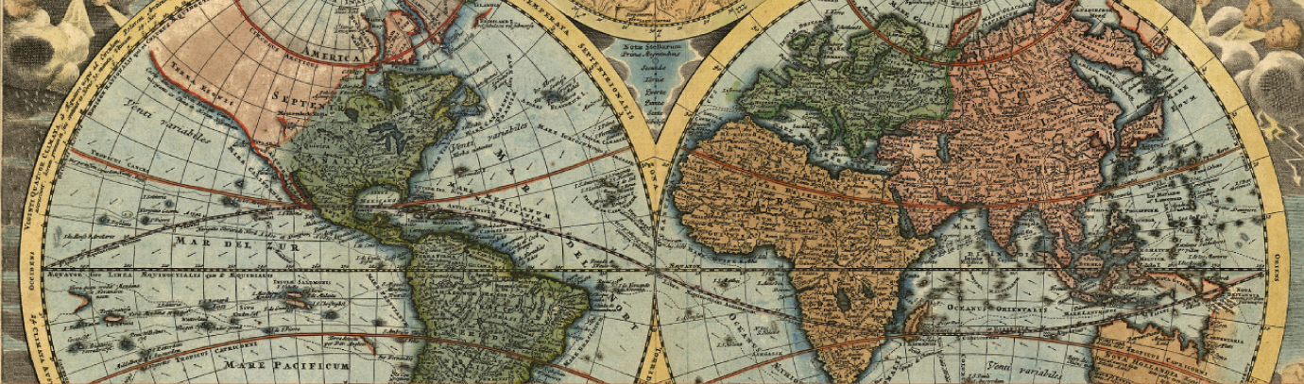
Unit 7 Section 2
Course overview: World History is a survey course covering from early civilizations to modern times, with emphasis on the political and philosophical roots of western democracy. Topics include: the rise of democratic governments; political, social and economic developments of the Middle Ages; the Renaissance and era of discovery; the growth of democracy and nationalism; the industrial revolution; and the two world wars. Postwar problems and recent developments are also studied.
Unit 7 Overview: Students will also analyze the birth of the Industrial Age and evaluate how the change in industrial processes and the rise of cities changed the way people live and interact with each other and the environment. They will examine the ever-increasing need for and consumption of natural resources, and will explore how industrialization changed the equation. Students will compare how diﬀerent societies adapted to the rapid growth of industry, and evaluate the reasons for the successes and failures based on each society's’ particular circumstances and factors.

CA State Standard:
10.3 Students analyze the effects of the Industrial Revolution in England, France, Germany, Japan, and the
United States.

Assignments:

Worksheet: Communism Ideals
Chapter 24 Lesson 1: The Growth of Industrial Prosperity
Worksheet: The Rise of Trade Unions
Chapter 24 Lesson 2: The Emergence of Mass Society
Worksheet: Henry Mayhew
Chapter 24 Lesson 3: The National State and Democracy
Worksheet: People of Change
Chapter 24 Lesson 4: Modern Ideas and Uncertainty
Worksheet: People of Science
Check-in 7.2
Unit 7 Test

Packet Directions
- These packets are assessed course work.
- You will be scored based upon completion, effort, and accuracy.
- All short answer questions are to be completed IN YOUR OWN WORDS!
Unless a question specifically asks you to cite or quote from the text, answers copied word for word or cut and pasted from the online text (even with quotations) will be treated as copied and marked down. (See Inspire’s plagiarism policy in your course syllabus)
- When typing your responses please keep your answers in red font (when red font is provided)
- Packets are required to be uploaded as one whole unit and as one file (see the syllabus for details)
- Name and date are required! You will lose points if you leave them off!

-Content Vocabulary-
Directions: complete vocabulary words as you complete the unit, these may be copied from the text.
Bourgeoisie | The middle class people in society
Proletariat | The working class people
Revisionists | Supporters of a policy of modification
Feminism | The advocacy of the rights of women regarding equality of sexes
Duma | A Russian assembly with legislative functions
Social Darwinism | The believe in survival of the fittest
Pogroms | An organized massacre of a particular ethnic group
Zionism | The movement that sought to restablish and develop as well as protect the Jewish nation

-Don’t forget about Key Assignment #7 due 3/16-

-Worksheet: Communism Ideals-
As a critical thinker, you should ask yourself a variety of questions about the context in which an historical work of art was created. When the work is a political poster or other political image, it is important to look carefully at the meaning of both images and words to identify the intended audience, interpret the message, and recognize any evidence of bias or propaganda.

Directions: The poster, a woodcut from a nineteenth-century German magazine, illustrates the socialist ideal of workers uniting to create a classless society. Look closely at the poster, analyze it, and answer the questions that follow.
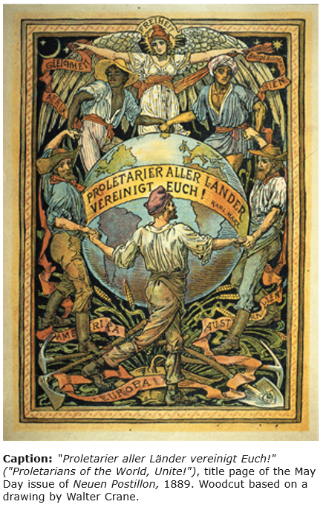
Background
The shift from a rural to an urban way of life had serious consequences for the working class during the Industrial Revolution. Poor housing and sanitation, dangerous working conditions, and long hours with low wages and no benefits plagued workers in the new economy. Radical reformers called socialists blamed capitalism for these ills. Many of them believed that violent revolution was necessary in order to bring about social reform.

Socialists based their ideas on theories of German philosopher and economist Karl Marx (1818–1883). With German philosopher Friedrich Engels (1820–1895), Marx had written the key work of the socialist movement: The Communist Manifesto. In this influential 1848 book, the authors expressed their belief that the proletariat, or working class, would have to violently revolt against the bourgeoisie in order to achieve a balanced society. Once workers had overthrown the bourgeoisie, they would be the ruling class and form a dictatorship in which capital and the means of production would be controlled by the State. Marx believed that a “classless” society with an even distribution of wealth would result. Marx-influenced reformers formed various socialist parties throughout Europe. The strongest and most influential was the German Social Democratic Party, or SPD (for Sozialdemokratische Partei Deutschlands), created in 1875.

The poster "Proletarier aller Länder vereinigt Euch!" ("Proletarians of the World, Unite!") is a woodcut based on a drawing by the famous British children’s book illustrator Walter Crane (1845–1915), who sympathized with the socialist cause. The image appeared in 1889, the year in which the SPD and other socialist parties and trade unions in Europe and North America formed a socialist federation called the Second International in Paris. One of the first acts of the Second International was to declare May 1 as International Workers Day in support of the labor movement in the United States, which was lobbying for an eight-hour workday. This poster celebrates the political power of the proletariat, using the famous call to unity that appears at the end of The Communist Manifesto: “Workers of All Countries, Unite!” Authorities in Germany feared that the May Day celebration might spark strikes and violent riots. Their fears were unnecessary; the first May Day, in 1890, passed with only nonviolent protests.

Worksheet: Communism Ideals – questions
1. Describing
What visual details stand out most for you in this poster?
Answer: the togetherness depicted by people holding hands together

2. Analyzing
a) For what audience do you think this illustration was designed?
b) How do the images in this illustration appeal to that target audience?

Answer a): workers

Answer b): It appeals to the employees to united to achieve the goals of the organization

3. Summarizing
Consider the words that appear on the top of the image (Freiheit, Gleichhight, and Brüderlichkeit, or “Liberty, Equality, and Fraternity”) as well as the Karl Marx quote and the names of countries and continents.
a) What is the central message of this poster?
b) Describe how the words and images create this message.
Answer a): diversity should be embraced at workplace

Answer b): the employees in the image come from different cultures but they have been united in the way they are doing the organization they are working for

4. Evaluating a Perspective
Propaganda is a persuasive technique that presents a one-sided, emot beionally loaded message in favor of (or against) a particular cause, group, or idea. The goal of propaganda is to influence people’s emotions in order to gain their support or change their minds. What propaganda elements do you see in this woodcut and what is their intended effect?
Answer: __________

-Chapter 24 Lesson 1: The Growth of Industrial Prosperity-
Directions: Read each main idea. Use your textbook to supply the details that support or explain each main idea.
A. Main Idea: In the Second Industrial Revolution, steel, chemicals, electricity, and petroleum led the way to new industrial frontiers.

1. Detail: The Second Industrial Revolution was spurred by inventions such as the _____Bessemer_____________ process for steel production and the use of _____electricity___________ to power homes and factories.
2. Detail: Lightbulbs were invented by ____Thomas Edison______________ in the United States and by _____Joseph Swan_____________ in Great Britain.
3. Detail: __Alexender Graham Bell_______________ ’s invention of the telephone and ___Guglielmo Marconi_____________ ’s breakthroughs with radio waves set off a revolution in communications.
4. Detail: Mass transportation improved with the invention of the ____internal-combustion____________ engine. This engine gave rise to ____ocean liners______________ and __oil-fired engines________________ .
5. Detail: Henry Ford’s invention of a new manufacturing method known as the ___assembly line_______________ allowed for the __mass production________________ of goods.
6. Detail: In Europe and throughout the world, ____industrialized______________ urban economies experienced a higher ____living standards______________ than agricultural economies.

B. Main Idea: Poor working and living conditions led many industrial workers to form socialist political parties and socialist trade unions in a bid to improve their lives.

1. Detail: In their publication __the communist manifesto________________ , Karl Marx and Friedrich Engels blamed ___induatrial factories_______________ for poor conditions in industrial factories.
2. Detail: Marx believed that world history was characterized by _class_________________ struggles over the means of ___production_______________ .
3. Detail: Marx believed society was splitting into two hostile camps, middle-class ____Bourgeouise______________ oppressors and the working-class __proletariata ________________ .
4. Detail: Pure Marxists thought capitalism could be defeated only by ___a violent revolution_______________ , but __revisionists________________ argued for political involvement and reform.
5. Detail: Workers organized _in a union_________________ to improve their working conditions through the right to ______strike____________ .

Summary & Reflection

Directions: Using ideas from throughout the entire lesson, summarize the main ideas by answering the question below. Answers must be IN YOU OWN WORDS. Point awarded based on accuracy and effort.
How did the Second Industrial Revolution shape urban life?
Answer: Urban life remained harsh for the poor, despite efforts to improve cities. They lived in small, cramped row houses or tenements in overcrowded neighborhoods. Unemployment and illness meant lost wages.

-Worksheet: The Rise of Trade Unions-
The Rise of the Trade Unions
The First and Second Industrial Revolutions created a huge labor force in the major population centers of Europe and the United States. As long as this labor force was not united, employers could easily take advantage of workers by requiring long hours, offering low wages, and maintaining unsafe conditions. Workers could improve their lot only if they stood together.
Workers began to unite in small groups in eighteenth-century Britain, but these associations were not very successful through most of the nineteenth century. Their ineffectiveness was influenced by hostility and resentment from employers who wanted to protect their own interests and maximize their profits. During these early years of economic activism, both Britain and the United States prosecuted trade unions and union activists.
Each country’s workers took different approaches to organizing unions. In Britain, the movement turned to political activism, leading to the 1906 formation of the Labor Party. In the United States, on the other hand, unions pursued collective bargaining in order to gain better economic conditions for their workers.
As long as it was illegal to go on strike, unions had no leverage with employers. New laws being passed in Britain and the United States helped workers gain some of that leverage. In Britain, the Trade-Union Act of 1871 gave unions the right to strike. In the United States, a series of court decisions slowly outlawed the use of injunctions, conspiracy laws, and other tactics against unions. In 1886, several unions of skilled workers united to form the American Federation of Labor (AFL), and a large-scale labor movement in the United States began. The AFL negotiated wages, hours, benefits, and working conditions for the U.S. employees.

Applying Economics to History
1. Explaining: Why were early trade unions so ineffective?
Answer: most companies used workers outside the union.

2. Comparing and Contrasting What are the similarities and differences in the history of trade unions in Britain and the United States?
Answer: both trade unions in Britain and in the U.S existed to fight for the rights of workers. However, the origin of the power of trade unions in the U.S and Britain is different

-Chapter 24 Lesson 2: The Emergence of Mass Society-
Directions: Read the lesson and complete the outline below. Refer to your textbook to fill in the blanks.
I. The New Urban Environment
A. Industrialized cities improved life by addressing concerns about _____housing___________ and public _______health_________ .
B. Improvements in housing came through building regulations requiring _running water_________________ and internal ______drainage____________ systems in new buildings.
C. Improvements in water quality came from improved aqueducts, tunnels, and reservoirs; gas and electric water _______heaters___________ ; and _____sewage_____________ treatment systems.

II. Social Structure of Mass Society
A. Europe’s elite made up ____5%______________ of the population but controlled ______30%____________ of the wealth.
B. The ___upper middle_______________ class included industrialists and bankers; the ___middle lower_______________ class included lawyers, doctors, and accountants; and the ______middle____________ class included traders and prosperous farmers.
C. The middle-class ideal included a belief in hard ______work____________ and the importance of outward __appearances________________ .

III. Women’s Experiences
A. During the Second Industrial Revolution, some women found employment in low-paying __white collar________________ jobs and jobs in health, education, and social _____services_____________ .
B. Modern ____feminism______________ began in the late eighteenth century when some Enlightenment thinkers argued that _____vote_____________ was a natural right for women as well as men.
C. Nineteenth-century ___activists_______________ such as Emmeline Pankhurst and her daughters demonstrated for the right to ____protest______________ .

IV. Education and Leisure
A. _____public_____________ education helped develop a trained workforce and instill patriotism.
B. The Second Industrial Revolution produced new forms of mass leisure at dance halls and ___amusememt______________ parks and through ____team______________ sports.

Summary & Reflection

Directions: Using ideas from throughout the entire lesson, summarize the main ideas by answering the question below. Answers must be IN YOU OWN WORDS. Point awarded based on accuracy and effort.

How did industrialization affect political and social structures?
Answer: industrialization solidified the positions of upper and lower class. Also, the factory workers did not earn enough to better their social standings.

-Worksheet: Henry Mayhew-
Background
In Victorian England, economic changes brought about by the Second Industrial Revolution motivated individuals of virtually every rank in society to improve their lives. The formula, preached by the upper-middle-class guardians of the public good, was a simple one: Hard work led to respect, which then led to advancement, which in turn led to success. Workers in the skilled and semiskilled trades formed unions, and by 1872 had begun attempts to organize even unskilled day laborers in order to procure “the full value for their labor . . . [and] to diminish the hours of labor . . . as is consistent with man’s moral and physical nature.” Lower-middle-class shopkeepers, salespersons, and office clerks took seriously the advice offered in Samuel Smiles’s popular self-help books: “It is the diligent hand . . . that maketh rich—in self-culture, growth in wisdom, and in business. . . . An hour wasted daily . . . if devoted [instead] to self-improvement, make[s] an ignorant man wise . . . [and] his life fruitful.”

For ambitious upper-middle-class industrialists, manufacturers, and bankers, success meant achieving a position that previously had been fully enjoyed only by the aristocratic elite. Though claiming work as a worthy end in itself, many of them worked consciously or unconsciously to obtain the life of an English gentleman: a mansion with stables and a coachhouse, a park, a large garden and hothouses, pleasant carriage drives, a gracious wife, ball gowns for their daughters, and hunts for their sons. In practice, achieving that success in the fiercely competitive commercial world often meant placing personal gain ahead of the public good. Instead of helping the poor, those who achieved success began to think of their own improvement over the improvement of society as a whole. By the end of the nineteenth century, the possibility of self-improvement had altered English society, which soon emphasized personal wealth and achievement at any cost.

Directions: Read the selections below. Then answer the questions that follow – IN YOUR OWN WORDS

It is a sight to sadden the most callous, to see thousands of men struggling for only one day’s hire . . . [knowing] that hundreds out of the number there assembled must be left to idle the day out in want. To look in the faces of that hungry crowd is to see a sight that must be remembered. . . . The room was about 7 feet square, and, with the man and wife, there were eight human creatures living in it. In the middle of the apartment, upon a chair, stood a washing-tub foaming with fresh suds, and from the white crinkled hands of the wife it was plain that I had interrupted her in [doing laundry she had taken in to earn money]. . . . On my observing that I supposed she dried the clothes in that room, she told me that they were obliged to do so, and it gave them all colds and bad eyes.
—Henry Mayhew, from London Labour and the London Poor, 1851

. . . [Worth] had been trained as a salesman at Allenby’s—a small dressgoods house near Regent Street—and had been so successful that at thirteen he was made the firm’s cashier. . . . Before his seventeenth birthday he set off for Paris with five pounds lent by his mother, a short reference from Mr Allenby and no knowledge of the French language. . . . Within a year he joined the staff of Maison Gagelin the first house in Paris to sell ready-made coats and cashmere shawls to fashionable women and it was not long before he suggested that the house should design dresses to suit the individual type and personality of each customer. Madame Gagelin was shocked to the core and Worth left her to set up a business of his own. . .
—A. H. Beck, from “The House of Worth,” 1950

It was the bounden duty of every citizen to better his social status; to ignore those beneath him, and to aim steadily at the top rung of the social ladder. . . . [My father] was an honourable and loyal colleague; he retained thoroughout his life the close friendship of his partners . . . he was generous in giving credit to subordinates. . . . But he thought, felt, and acted in terms of personal relationship and not in terms of general principles; he had no clear vision of the public good. . . . Hence he tended to prefer the welfare of his family and personal friends to the interests of the companies over which he presided, the profits of the companies to the prosperity of his country, the dominance of his own race to the peace of the world.
—Beatrice Webb, from My Apprenticeship, 192
Worksheet: Henry Mayhew- Questions

1. Analyzing Primary Sources
a) What disturbed Henry Mayhew about the scene he observed at the dockyards?
b) What conditions existed in the home he visited?
c) Why do you think the wife had to take in laundry?
d) How might this family have benefited from the organization of a union of unskilled laborers?
Answer a): to see thousands of men struggling for only one day’s hire knowing that hundreds out of the number there assembled must be left to idle the day out in want

Answer b): poor conditions as eight people lived in one small room

Answer c): to get income to feed the family

Answer d): the unskilled labor union procured the labor of unskilled labor

2. Drawing Conclusions
Describe how Charles Frederick Worth improved his position in the business world. In what ways did Worth illustrate qualities or practices that Samuel Smiles recommended in his self-help books?
Answer: Frederick Worth improved his position by creating the first fashion empire. He illustrated Samuel Smiles by dictating his style preferences to the crowned heads of Europe.

3. Identifying Perspectives
a) According to Beatrice Webb, how did her father relate outwardly to his business associates?
b) What priorities governed his business decisions, and
c) what concerns was he willing to sacrifice in order to achieve these priorities?

Answer a): he retained throughout his life the close friendship of his partners

Answer b): he thought, felt, and acted in terms of personal relationship and not in terms of general principles; he had no clear vision of the public good

Answer c): he tended to prefer the welfare of his family and personal friends to the interests of the companies over which he presided, the profits of the companies to the prosperity of his country

-Chapter 24 Lesson 3: The National State and Democracy-
Directions: Locate each heading below in your textbook. Then use the information under the correct heading and subheading to help you summarized each answer.
I. Western Europe: Political Democracy
A. What were three signs that democracy was expanding in Western Europe?
Answer: Universal male suffrage laws were passed, the prime minister was responsible to the legislative body, and political parties formed

B. a) What were the three main political parties in Great Britain during the 1800 and 1900s?
b) Describe the efforts made by each to gain popular support.
Answer a): Liberals, conservatives, and Labour Party

Answer b): the liberals encouraged people to express their views. The conservatives maintained the norms and thereby gaining support of the others while the Labor party appealed to the workers.

II. Central and Eastern Europe: The Old Order
A. How were the governments of Germany and Austria-Hungary different from the government of France in the late 1800s?
Answer: Germany/Austria-Hungary was different from France because they had more conservative governments and their old ruling groups continued to dominate politics.

B. a) What led to the creation of the Duma in Russia, and b) what was its purpose?
Answer a): workers through Russia were on strike.

Answer b): Its purpose was to temporarily calm things down.

III. The United States
A. How did the shift from a farm-based economy to an industrial one change the United States?
Answer: Urbanization, and they became the worlds riches nation

B. What was the result of the United States victory in the Spanish-American War?
Answer: They got more land

IV. International Rivalries
A. a) What led to the alliance of Great Britain, France, and Russia? b) What nations were they aligned against?

Answer a): Germanys emergence in 1871 as the most powerful state in continental Europe had upset the balance of power.

Answer b): Bismark made a defensive alliance with Austria Hungary.

B. What helped to push Europe close to war by the beginning of 1914?
Answer: The allies of Austria Hungary and Russia were determined to support their respective allies more strongly in another crisis. By the beginning of 1914, these countries viewed each other with suspicion.

Summary & Reflection

Directions: Using ideas from throughout the entire lesson, summarize the main ideas by answering the question below. Answers must be IN YOU OWN WORDS. Point awarded based on accuracy and effort.

How did industrialization cause political and social changes in Europe and the United States during this period?
Answer: The industrial revolution in Britain affected society, politics and the economy by increasing work output, creating the working class, dividing classes, having women began working, creating area specialization, seeing politics shift to appeal to working class men as they were now the majority of the people and current workers being unable to strike for fear of being replaced by immigrant workers. The population increased dramatically during the industrial revolution as well so cities and infrastructure grew rapidly

-Worksheet: People of Change-
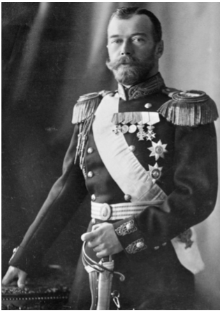
Nicholas II (1868–1918)
Nicholas II was the last emperor of Russia. The eldest son of Alexander III, he was crowned czar in 1896. At the beginning of his rule, Czar Nicholas II said, “I shall maintain the principle of autocracy just as firmly and unflinchingly as did my unforgettable father.” Nicholas was an autocratic emperor, but he had received little training for his role. A disastrous loss in the Russo-Japanese War (1904–1905) paved the way for the Russian Revolution of 1905 and the creation of the Duma, or parliament. However, Nicholas restricted parliament’s powers, and internal problems increased. During World War I, Nicholas took charge of the armies and left domestic affairs to his wife, Alexandra, and her advisor, Grigory Rasputin. Neither Alexandra nor Rasputin cared about social reform. Growing discontent among Russian citizens led to the Russian Revolution of 1917. Nicholas II abdicated the throne in favor of his brother Michael, but Michael refused to take it. In 1918, the Bolsheviks executed Nicholas and his entire family.
More About the Image: The death of Nicholas II and his family marked the end of the Romanov dynasty that had ruled Russia since 1613.

1. Analyzing Information How did Nicholas maintain autocratic rule?
Answer: by following the footsteps of his forefathers

2. Drawing Conclusions What caused Nicholas to abdicate the throne in 1917?
Answer: the Petersburg riots mutinied and Nicholas had no choice but to abdicate the throne

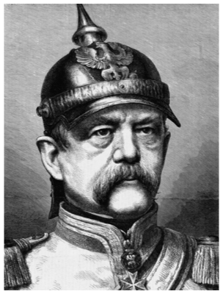
Otto von Bismarck (1815–1898)
Otto von Bismarck came from a class of aristocratic Prussian landowners known as Junkers. Under his leadership, Prussia won a series of European wars that united the German states under Prussian rule. Bismarck became a national hero. In 1871, when King William I of Prussia was proclaimed the German Kaiser, Bismarck became chancellor of this new German empire. After Bismarck became chancellor, he forged alliances against France and introduced administrative and economic reforms. The empire also built up its industries and established colonies in Africa and the Pacific.
More About the Image: This anonymous engraving of Bismarck was created in 1871, the year of German unification

1. Analyzing Information
What role did Otto von Bismarck play in helping Germany achieve unification?
Answer: He strengthened the position of Prussia in Europe to unify the north German states under Prussian control.

2. Making Connections
How did Bismarck establish control as chancellor?
Answer: Bismarck did serve the Prussian King as a prime minister and later the German Emperor as a chancellor, so he was installed by the monarch as his right hand. His legal authority was derived from the authority of the monarch

-Chapter 24 Lesson 4: Modern Ideas and Uncertainty-
Directions: Read each main idea and answer the questions below. Refer to your textbook to write the answers.
A. Main Idea: In the late 1800s literature, the visual arts, music, and architecture departed from tradition to create innovative artistic works in a movement known as modernism.

1. What did symbolist writers believe?
Answer: The external world including art, was only a collection of symbols reflecting the human mind. Also, art should function for its own sake, not criticize or see understand society

2. What were impressionism and postimpressionism?
Answer: Impressionism: concentrated on the effect of natural light on objects
Post-impressionism: More vivid colors, didn't care as much about light

3. How did postimpressionism lead to other styles of painting?
Answer: It opened the door to people seeking other types of art

B. Main Idea: Scientific discoveries in the late 1800s led many people, including artists, to question the way they saw themselves and the world around them.

1. Who was Marie Curie? Include specific details from the text.
Answer: was a physicist and a chemist Discovered radioactivity

2. What did Albert Einstein conclude in his theory of relativity?
Answer: He concluded that due to gravity time may be relative

3. Who was Sigmund Freud? Include specific details from the text.
Answer: Sigmund Freud was an Austrian neurologist who founded the discipline of psychoanalysis.

C. Main Idea: Extreme nationalism was reflected in the movements of Social Darwinism and anti-Semitism in the late 1800s.

1. What was Social Darwinism?
Answer: The application of survival of the fittest to society

2. How did nationalists use Social Darwinism?
Answer: They used it as a way to prop themselves up and oppress other peoples

3. How did anti-Semitism help give rise to Zionism in the late 1800s?
Answer: Well antisemitism being the hatred of Jew expressed through words or actions and Zionism being the event of Jews seeking refuge in Palestine. It is no surprise that Jews committed to Zionism due to antisemitism

Summary & Reflection

Directions: Using ideas from throughout the entire lesson, summarize the main ideas by answering the question below. Answers must be IN YOU OWN WORDS. Point awarded based on accuracy and effort.

How did industrial, artistic, scientific, and political changes in the late 1800s contribute to a changed worldview?
Answer: __________
Industrial - new ideas led to new technologies and led people to be conceded of their countries
Artistic - painters began painting more realistic paintings, making people likely feel more advanced
Scientific - people began progressing through science very rapidly making important discoveries constantly
Political - people began getting too confident in their home countries and some became nationalists

-Worksheet: People of Science-
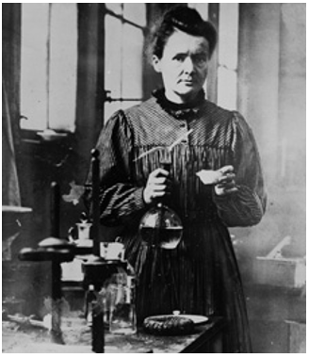
Marie Curie (1867–1934)
Marie Curie was born Maria Skłodowska in Warsaw, Poland. In 1891, she went to Paris to study at the Sorbonne, where she excelled in math and science. Marie married physicist Pierre Curie in 1895. The two developed a theory based on Henri Becquerel’s discovery of radioactivity in 1896, developed techniques for isolating radioactive isotopes (atoms with the same atomic number but different physical properties), and discovered the elements polonium and radium. In 1903, Marie Curie became the first woman to win a Nobel Prize, sharing the award with her husband and Becquerel. In 1911, Marie alone won the Nobel Prize in Chemistry. She devoted the rest of her life to finding medical applications for radioactive substances. Marie Curie died in 1934 of leukemia, brought on by decades of exposure to radioactivity. More About the Image: This photograph was taken in 1910.
1. Making Generalizations
In what way might Marie Curie’s career have affected how other women saw themselves?
Answer: It empowered other women by making them believe that they can do the things that men do in society

2. Drawing Inferences
Besides her specific scientific achievements, how else did Marie Curie affect the world?
Answer: She inspired the world

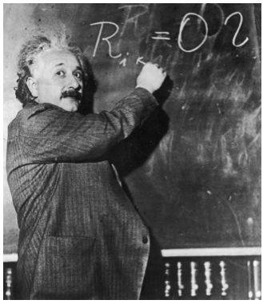
Albert Einstein (1879–1955)
Albert Einstein was a physicist. He was born to Jewish parents in Ulm, Germany. He studied physics and math in college, and he received his doctorate from the University of Zurich in 1905. That year, he published four major research papers, including two on his special theory of relativity, that changed the way people thought about the universe. This theory asserted that distance and time must be relative, depending on the observer. In 1921, Einstein received the Nobel Prize in Physics. When the Nazi Party took over Germany in 1933, Einstein moved to the United States. During World War II, Einstein supported the construction of nuclear weapons to defeat the Nazis. However, after the war, Einstein tried to prevent the future use of atomic weapons.
More About the Image: Einstein posed for this 1930 photograph while writing a formula on a chalkboard.
1. Analyzing Information
How did Einstein lead many people to question the nature of reality?
Answer: In 1905 he published four major research papers, including two on his special theory of relativity, that changed the way people thought about the universe

2. Drawing Inferences
In what way did Einstein question his own scientific achievements?
Answer: by considering both the negative and positive sides of his scientific achievements.

-STOP!-
Do not move on to Unit 8 Section 1 until you have completed the Check-in 7.2.

-STOP!-
Do not move on to Unit 8 Section 1 until you have completed the Unit 7 Test.

-STOP!-
Key Assignment is due prior to taking the Unit Test and before moving to the next Unit.

